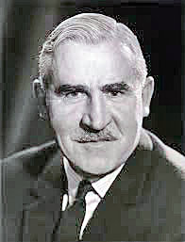

Obituary to Sir Martin Flett KCB

Sir Martin Flett KCB who died on February 25 1982 at the age of 70 was formerly Permanent Under-Secretary of State, Air Ministry.

He was educated at George Watson's School, St Paul's School and St John's College, Oxford, where he took a 1st in modern history in 1933. The same year he joined the Home Civil Service at the Dominions Ofice, moving to the Treasury in 1934.

From 1944 to 1946 he was at the War Cabinet Office, Ministry of Reconstruction and the Lord President's Office. From 1949 to 1956 he was an Under-Secretary at the Treasury, and then served in Washington as alternate UK director at the International Bank and as Financial Counsellor, British Embassy.

From 1956 to 1961 he was Deputy Secretary, Ministry of Power. In 1961 he was transferred to the Air Ministry as Deputy Under-Secretary of State; in 1963 he succeeded Sir Maurice Dean as Permanent Under-Secretary of State (RAF) in the new unified Ministry of Defence, and from 1968 he was responsible for Equipment at that ministry.

After his retirement he was for 8 years a director of Decca Ltd, and was also a director of Siebe Gorman Holdings Ltd.

