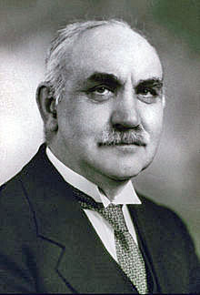

Obituary to Sir John Smith Flett KBE, FRS

John Smith Flett, who died on 26 January 1947, at the age of seventy-seven, has left an abiding mark on British geology, both as a scientific investigator and as an official administrator. His scientific contributions dealt mainly with petrography and many of them were necessarily of a routine and official character. His greatest services to his science were undoubtedly those given during his fifteen years as Director of His Majesty’s Geological Survey. In the unsettled and transitional period between the wars, it was indeed fortunate for the Survey and for geology that a man of Flett’s stamp—in intellect keen and acute, in character resolute and virile—should be at the helm. Under his guidance there arose the magnificent Geological Museum at South Kensington —a monument to a vision persistently followed. When we contemplate the outstanding part that the geologists of this small island have played in the foundation and evolution of their science, we must rejoice that at last an exhibition worthy of that record can be made. Flett was born in Kirkwall, Orkney, and received his early education at the Burgh School of that town. He passed to George Watson’s College, Edinburgh, and thence to the University of Edinburgh, where he graduated M.A., B.Sc. (with honours in Natural Science), in 1892 and M.B., C.M., in 1894. During his academic career he gained an extraordinary variety of prizes, medals and scholarships. This was no ephemeral brilliance or inclination, and he maintained an interest in subjects outside his professional orbit all his life; he was especially attracted to literature of a somewhat caustic or satiric cast. After graduation, Flett was for a short time in medical practice but, in 1895, he forsook that career and turned himself for good to geology.

